UI/UX

Domain:Telemedicine
Sites:1mg,Pharmeasy,esanjeevani,apollo 24|7

Name:Jinali Jain
PRN:1266243057
Roll No:23
Panel:F

- Critical Analysis of Interfaces: Analyse any one interface (website or mobile app) that you have interacted with that could be designed better. Focus on the interface design problems, rather than their engineering faults or business problems. Comment on its learnability, usability, consistency and metaphors.

- 1mg

PARAMETER | SCORE | DESCRIPTION
Learnability | 9 | Homepage is easy to understand with clear instruction for first time user.
Usability | 9 | Easy to search for medicines or to consult doctors.
Consistency | 9 | Design is same throughout whole page.
Use of Metaphors | 9 | Uses familiar metaphors like cart , search etc.
Navigation Structure | 9 | Search bars and menu are organized.
Visual Hierarchy | 9 | All important information is highlighted .
Accessibility | 8 | Website is usable for everyone .
Responsiveness | 9 | Website works properly on all devices.
Efficiency of Interaction | 9 | Tasks can be completed in very few steps.
Feedback and System Status | 9 | Clear messages which keep user informed.
Error Prevention and Recovery | 8 | Helps user to avoid mistake and help to resolve mistakes.
Aesthetic and Minimalist Design | 8 | No unnecessary information on home page except for so many ads.
Content Readability | 9 | Font size is good.
Search and Discoverability | 10 | Has filters which makes searching easy for user.
Performance Perception | 9 | Takes less time for searching.
Trust and Credibility | 9 | Trustable doctors and secure payment.
Personalization | 9 | Personalized recommendation based on user’s need and provides us with order history.
User Satisfaction | 9
  Smooth experience and easy to use .



- Pharmeasy

PARAMETER | SCORE | DESCRIPTION
Learnability | 9 | Homepage contains every detail need for first time user.
Usability | 9 | Very easy to use as it contains everything needed on front page .
Consistency | 9 | Use of proper color palettes and fonts.
Use of Metaphors | 9 | Metaphors like cart,search is used.
Navigation Structure | 9 | Filters are provided for efficient search.
Visual Hierarchy | 9 | All the actions are highlighted properly.
Accessibility | 8 | Useful to everyone .
Responsiveness | 9 | Layout changes according to device.
Efficiency of Interaction | 9 | Interaction is very easy and takes less step.
Feedback and System Status | 8 | Provides messages to user at every step.
Error Prevention and Recovery | 8 | Help user to enter correct details . for example: if you add address instead of name then it will tell us to correct it .
Aesthetic and Minimalist Design | 8 | Website look clean except for ads.
Content Readability | 9 | Text is easy to read.
Search and Discoverability | 10 | Search option , filters and recommendation which is very to useful to user is provided.
Performance Perception | 9 | Website works smoothly .
Trust and Credibility | 9 | Experienced doctors and secure payments.
Personalization | 9 | Provides recommendation based on user’s need and keeps data of previous order and past prescription.
User Satisfaction | 9 | Very easy to use for first time user also.

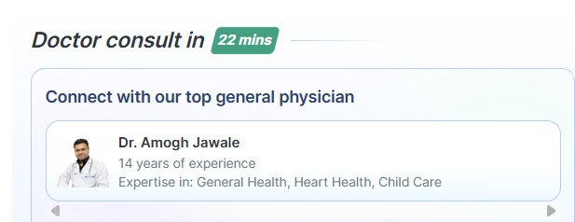

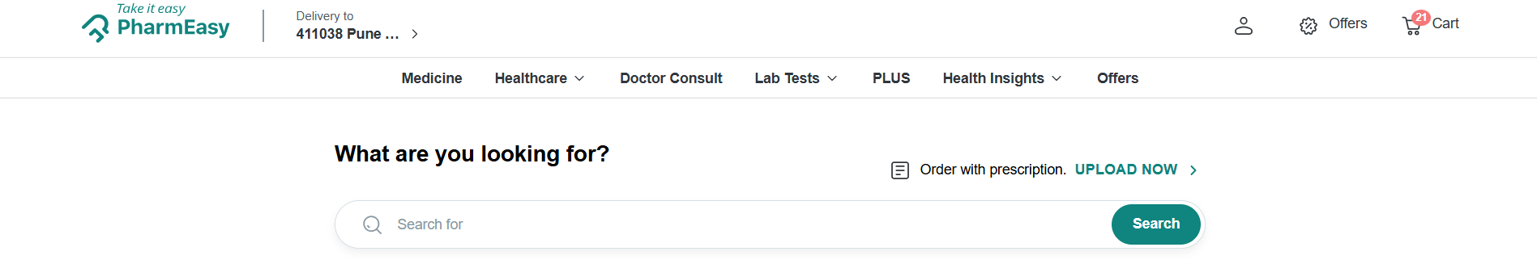

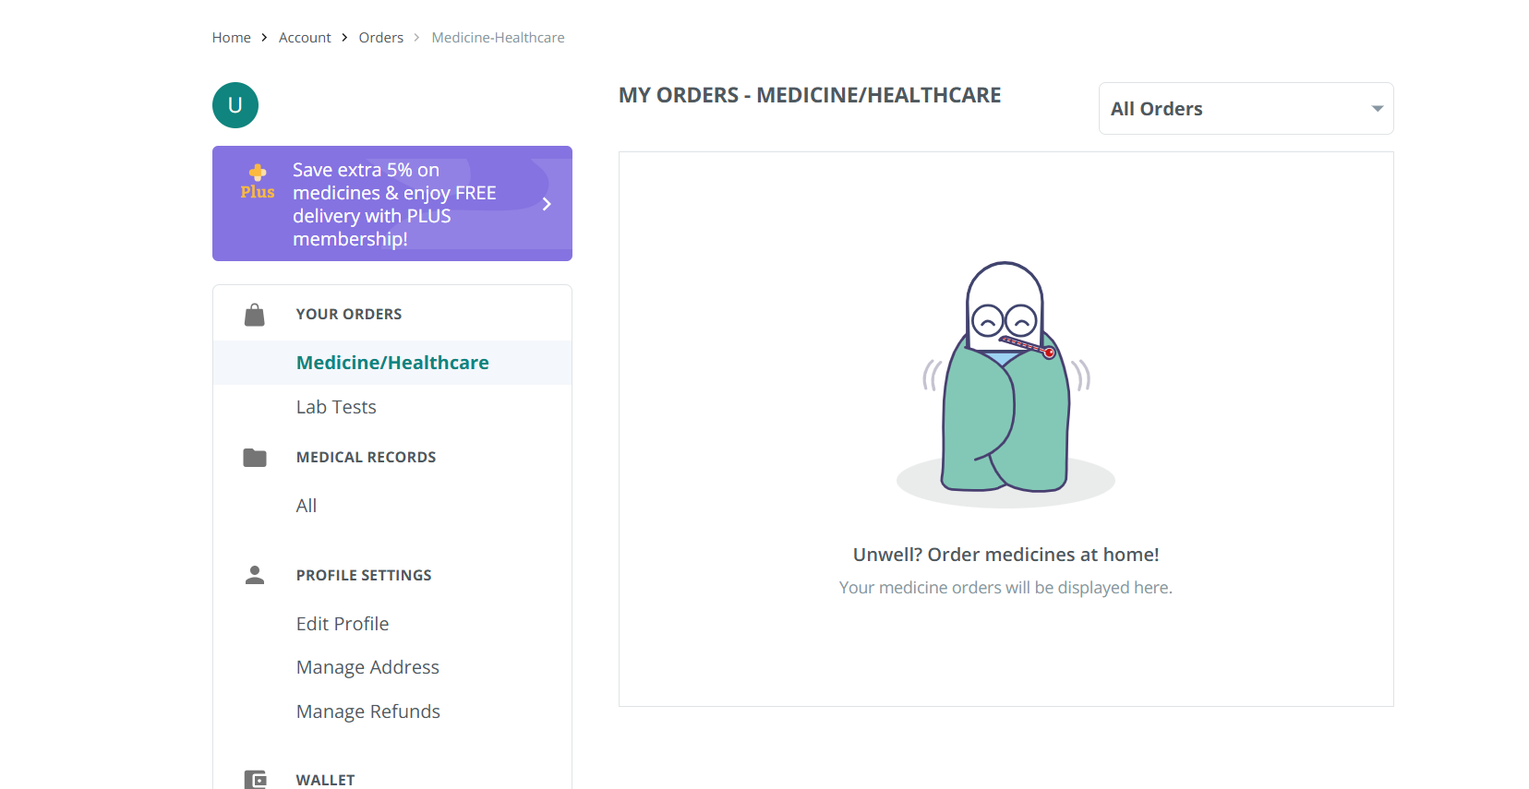

- Esanjeevani

PARAMETER | SCORE | DESCRIPTION
Learnability | 6 | First time user will find difficult to use it as login into app is complex and booking appointment is also difficult.
Usability | 7 | Using it is very complicated as it requires several steps to even book an appointment.
Consistency | 8 | Color palette and font is consistent throughout the page.
Use of Metaphors | 7 | Uses very common metaphors like profile.
Navigation Structure | 6 | It is difficult to move from one page to another as no proper instructions are given .
Visual Hierarchy | 6 | Buttons are not properly highlighted , one can find difficulty to locate the buttons.
Accessibility | 7 | Website access is difficult but fonts are readable.
Responsiveness | 7 | Layout needs some changes but works good on android but ios user may find it difficult to access it.
Efficiency of Interaction | 6 | It asks for same details repeatedly and booking requires many details.
Feedback and System Status | 7 | Feedback is minimal.
Error Prevention and Recovery | 7 | Asks user to confirm details but can improve error messages.
Aesthetic and Minimalist Design | 6 | Interface looks outdated .
Content Readability | 8 | Font size is good.
Search and Discoverability | 5 | No filter options are provided and searching is also not efficient.
Performance Perception | 7 | sometimes , works smoothly.
Trust and Credibility | 10 | No trust issues as it is government site.
Personalization | 5 | No personalized recommendation .
User Satisfaction | 7 | Service is good but UI can be more friendly.

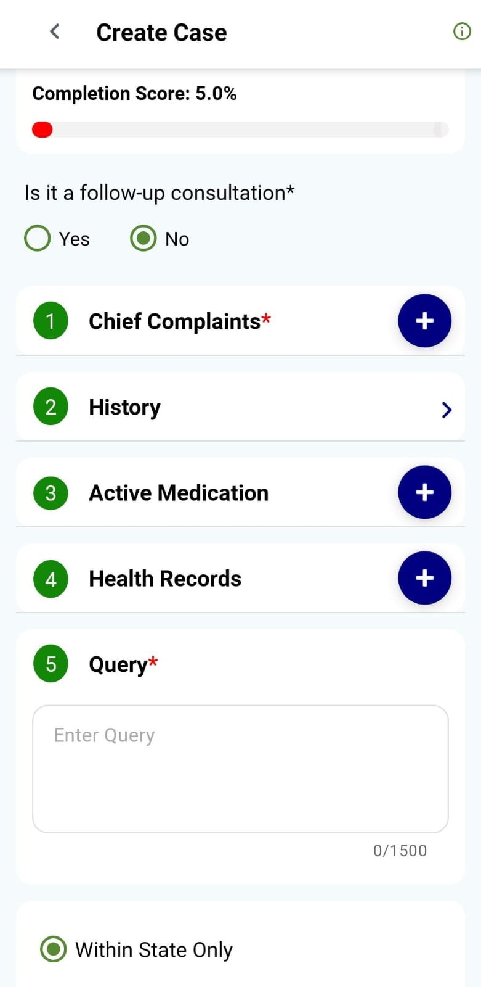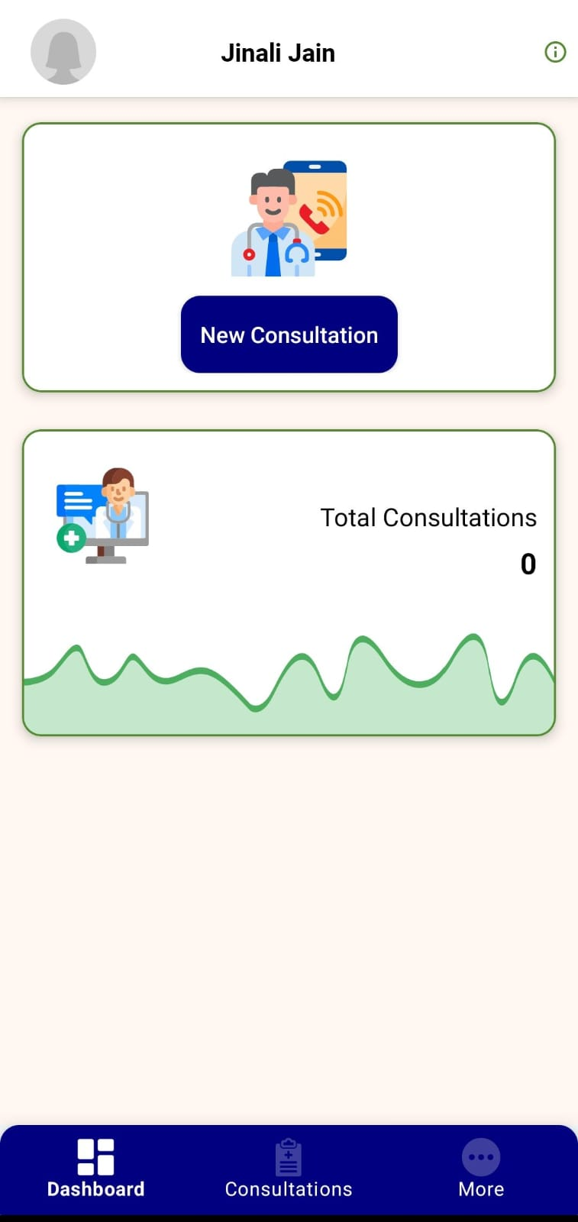
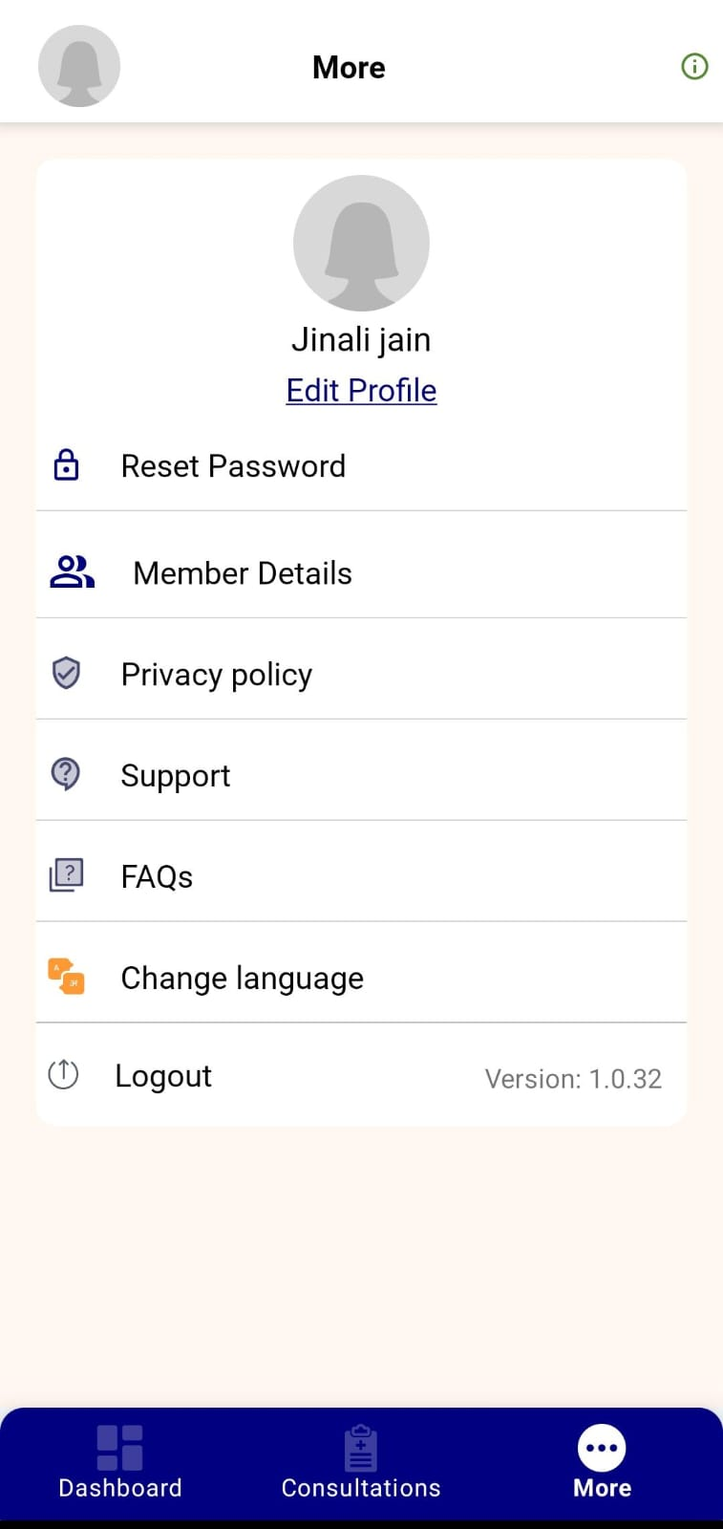

- Apollo 24|7

PARAMETER | SCORE | DESCRIPTION
Learnability | 8 | First time user can use it easily even though it contains many options on homepage.
Usability | 8 | Very easy to use as all details are provided on homepage.
Consistency | 9 | Similar design throughout the page.
Use of Metaphors | 9 | Uses metaphors like profile icon.
Navigation Structure | 8 | Sometimes it takes time to move from one page to another.
Visual Hierarchy | 8 | Important points are highlighted but too many ads .
Accessibility | 8 | Fonts are readable.
Responsiveness | 9 | Change its layout according to device.
Efficiency of Interaction | 8 | Most of the tasks are done within few steps.
Feedback and System Status | 8 | Asks confirmation from user at every step.
Error Prevention and Recovery | 8 | Provides clear messages .
Aesthetic and Minimalist Design | 8 | Design is maintained throughout the page even though page contains many things.
Content Readability | 8 | Font is readable.
Search and Discoverability | 9 | Searching is very easy.
Performance Perception | 8
  Works very smoothly.
Trust and Credibility | 10 | Trust is strong due to apollo hospital.
Personalization | 9 | Recommendation based on user need and can apply filter.
User Satisfaction | 9
  User can be satisfied using this because it is very easy to use.

